# Introduction

We are attempting to build a sustainable platform where recyclable garbage is efficiently directed, managed and recycled, through the idea of incentivizing individuals for their sorting contribution.

Our platform aims to solve the crisis by incentivizing individuals to throw, segregate, and understand the ‘critical’ recyclable garbage. The core is a mobile app that we will deploy so that existing disposal and collection infrastructure ecosystems can effectively collect the sorted garbage, and while doing so gather a wealth of data about the disposal patterns of users. Subsequently, our platform also doubles down to educate individuals of reducing, recusing, and recycling their waste. Thus it’s a positive feedback loop; better education leads to better sorting, which leads to more effective usage of the app, which will thus gather and learn further disposal trends. As such we believe this approach is highly scalable.

Once our app has a large enough user base, we will expand to encompass smart bins, which will seamlessly integrate to the system. They will be the last stage in the plan where we will leverage the disposal patterns for locations to effectively deploy the bins to areas to counter irresponsible disposal.

>> Gamification, psychology

# Sri Lanka’s Pain Points

>>

# 

# Existing solutions

There are a few existing local solutions to help cope with the various issues of recycling. A mention of a few respectable initiatives include;

* Plasticcycle - Plasticcycle has placed specially designed bins to support responsible disposal of recyclable plastic. Just wash, crush and drop off your recyclable plastic at a bin convenient to you. While John Keells Group companies, Keells and Elephant House are partners in this initiative, our efforts are backed by a commitment from Sri Lanka Recyclers <https://plasticcycle.lk/>
* Eco friends – is a responsible Waste management solution to all households in Sri Lanka. Very similar in business to ours employing the same idea as CityCollection. However, they do not carry out proprietary data analytics, and is a difficult business to scale given the asset heavy business model <<

<http://www.dailymirror.lk/mirror_for_hope/Rupees-for-Recycling/338-158701> Check

# Business model

So why are we different? Because our entire focus is on building an ecosystem that leverages the power of data and education.

The business's primary source of income is the recycler’s payment for recyclable items, which will be mainly used to sustain the collection expenses of the logistics system and user redemption, the core theme behind the application.

### Collection Model

The business relies on incentivizing customers which will require being able to uniquely ID their waste contribution. We will be providing users with their own unique QR codes and IDs, which will pasted onto their garbage disposal bags (which will be returned on their next scheduling).

Once a pickup is scheduled, our platform will route a truck (given sufficient collection quantity along the path). Where it will deliver the content to the sorting arm of the recycler.

Here the sorters will use the Validation app (see section XXX) to manually verify if the number entered by the user is the correct amount of recyclables. Once data is mapped to the user, we will provide the redemption when the cash is received from the recycler.

**Figure X: Our business model**

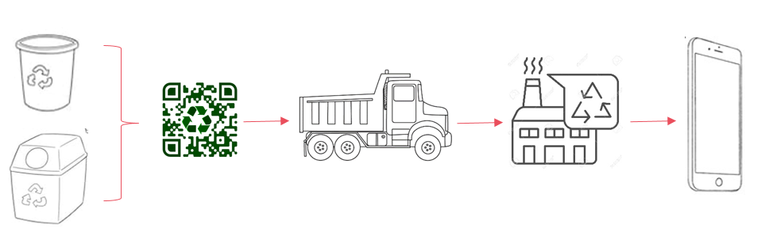

### Financial Model

Volume of recyclables is the key component of the system in that our apps collection and scheduling service aims to make the route optimization (via Google maps) as efficient as possible so that the logistics costs will be semi-fixed, thus driving operating leverage when volume grows.

**Figure X: Financial model**

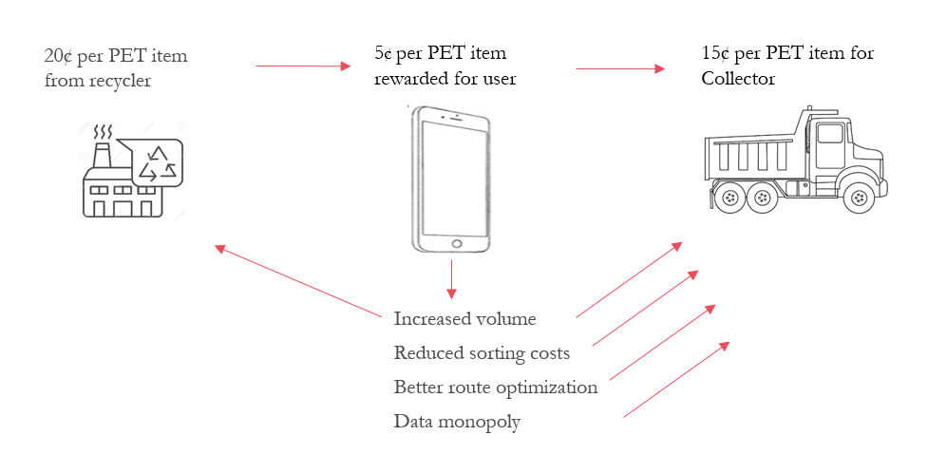

The current cost per mile of collecting PET items @500Kg truckload is **etc etc**

**Also as we** received from the recycler... (negative cash flow conversion)...

>> Include financial model/feasibility

# 

# The Platform

Our platform is effectively a mobile app, that will…

>> Describe the final solution API...

**Figure X: Our platform**

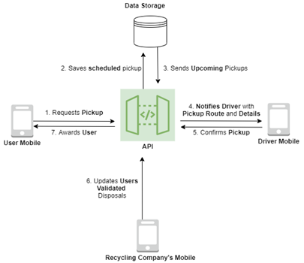

Currently, our working POC uses…

>> Describe the current set up ...

Our primary setup and stage one is called CityCollection, with stage two followed by CityBin both of which will eventually use our proprietary API.

1. Stage 1: CityCollection is the scalable solution designed to address household sorting and education
2. Stage 2: CityBin will address all disposal of garbage by including automated sorting bins

### CityCollection

>> image CityCollection

### CityBin

>> image CityBin

### Mobile App

Our mobile app is the core interface for the users and will have the following functionalities.

-Booking for pickups

-See previous bookings

-See upcoming pickups/cancel upcoming pickups

-See nearby bins

-See previous disposals

-Authentication

-Prize redemption

-News/Advertising

- Gamification

### Dashboard

-Visualize the data

-Waste disposal patterns/habits of users

-Waste disposal patterns of areas/cities

### 

### Crowdsourced Data

-Data gathered so far from a local survey includes

…

### Image recognition

We will be using image classification and object detection for CityCollection and CityBin respectively, but for different purposes.

**CityCollection - Object detection and classification:**

We are using the pre-trained YOLOv3 which we have trained on custom data that we have (crowdsourced data, described in section XXX). This model will be hosted in the cloud and identify specific brands. It is currently being trained to achieve high accuracy with high IOU

To gather sufficient data, we have to pay our customers (like Amazon’s mechanical turk) for labelling the dataset. We are currently building a system of redemption for the images through which we pay them a small fee for each labelled data. The income for this is expected to be launched through subscriptions by providing the crowdsourced data, or fully trained algorithm solution to industrial waste sorters and other interested disposal authorities. Naturally, we will not launch a payment until we have gathered evidence and struck a deal with said industrial data customers.

#### Results:

We are currently in the early stages of the training yet we are seeing convincing performance in our model. Our latest YoloV3 is capable of identifying 4 brands (trained purely through the crowdsourced image data; to be extended to >500 brands as data comes in) to achieve mAP of 70% @IOU of 60%.

**Figure 1: mAP of our custom YOLO object detection model**

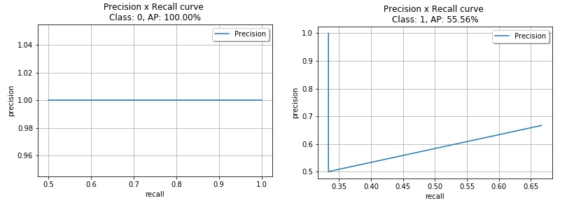

Our aim is to train the model to be capable of high mAP’s at high IOUs given the density of disposed items that may require detection at a sorting conveyor belt in an industrial use case.

We have used a variety of image augmentation tools, including changing hue, brightness, scaling, and background augmentation, to enable us to achieve this performance even with a small dataset. An example of the images are set below.

**Figure 2: Detections of out-of-sample items**

#### 

Currently, the algorithm is very effective in identifying the item when its brand is clearly visible, however it becomes less confident (and thus doesn’t recognise) when the brand/logo is unclear, stretched, distorted, etc. We are currently in the process of experimenting with a variety of blurring and shearing augmentations to overcome this issue.

#### 

**CityCollection - Object detection and classification:**

Our other model is a mobile friendly device and works by classifying singular items at a time. It works by identifying the broad categories of objects in an enclosed trap (i.e. CItyBins disposal box). We have used the Mobilenet model and trained the last 3 layers of the model to our dataset. The challenges are much more muted with the model given that we are operating in a predefined environment. Albeit the training data are also required to be in this environment, thus we are using a variety of background augmentation tools to build a suitable dataset.

**Figure 3: PET bottles in enclosure**

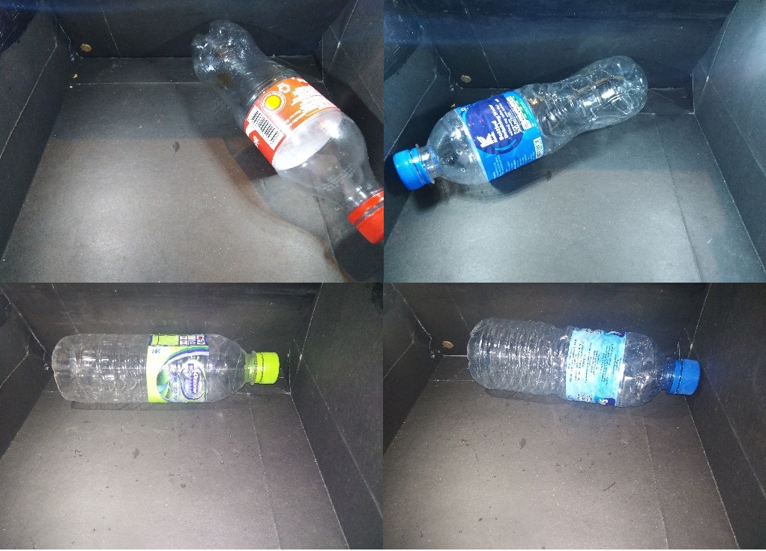

The model is capable of identifying PET bottles with >90% accuracy due to the constrained nature of the environment.

# How does it solve the problem?

To understand how our solution neatly addresses every problem in the challenge, either directly or indirectly, we have organised a Q&A session below.

## **Challenge 1 -** Improved Visibility of Plastic Waste Generation and Material Flows

* Southeast Asia’s existing systems are complex, often fragmented, and heavily reliant on the informal economy.
* Lack of visibility and transparency on plastic waste generation patterns as well as plastic waste material flows

Questions & Answers

1. How to better track and understand where plastic waste comes from and where does it go?

* The CC mobile app gathers information as to the houses that produce recyclables/non-recyclables via our QR code identification
* The dashboard tracks location, frequency, type, and even brand data via the image recognition portion of the app. The data is used to identify individual, community wise user patterns and behaviors to better focus collection efforts

1. Better understand waste generation based on its quality (type, cleanliness, etc) and source (urban/rural, commercial/household, community-level/country-level, etc)?

* CC & CB’s Image recognition to help identify the cleanliness and type of recyclability
* The app doubles down to track the brands that use plastics and other waste via the image recognition algorithm, which adds additional incentive rewards points (economics explained in the Our Platform section)
* Meanwhile, CB, our second iteration improves on the data collection procedure by going directly to the source of outdoor waste disposal (e.g. shopping malls, events) where CC influence is only indirect (home based solution that still incentivizes you to carry plastics home for recycling)

1. Predict the consumer attitudes and behaviors to identify potential channels of influence on plastics?

* As explained, the dashboard summarizes all of the relevant data to help identify individual and community wise user patterns. The app also has an ‘Awareness!’ section which displays weekly updates about plastic and waste related issues as heads up (not in a bothersome way!) This initiates public education of the responsible disposal of garbage

**Example solutions**

* Crowdsourcing data collection tool to map local plastic waste flows and stakeholders
* Data visualization tool to provide insights and forecasting on plastic waste flows
* A photo-sharing app that gathers location information on waste generation, aggregation centers, and markets
* A sensor technology that collects data on community-level waste disposal volumes and/or directional flows
* Image recognition technology that verifies waste volumes through photo capture
* Waste-shed modeling tools
* Data collection software and hardware that measures real-time community-level plastic waste generation
* Data analysis and visualization of product-specific data (including packaging materials) from brands, FMCG companies, and distribution networks to accurately capture plastic sources
* Data analysis which links retail consumption and producer’s plastic generation data with plastic waste disposal data to understand behavioral aspects and identify opportunities for intervention
* An innovative labelling technology (ex, QR code) that improve waste collection and recycling

## **Challenge 2** - Optimization of Circular Supply Chains for Plastics

* Collected-for-recycling rate of PET just ~26%, yet they import a large quantity
* Insufficient pricing of post-consumer materials/lack of visibility of post-consumer materials pricing for informal sector waste collection
* Lack of value creation mechanisms in the local supply chains
* Poor and short-term plastic waste collection efforts resulting in insufficient supply of quality, clean plastic feedstock
* Lack of new delivery models to eradicate usage of plastics

Questions & Answers

1. How might we incentivize responsible for plastic use and waste management?

* As mentioned, our CC system relies on two stage basis of incentification, 1. Recycler based incentives, 2. Image recognition drives marketing based incentives.
* Success rate of recycling is a direct function of the value of our incentive scheme. Our surveys across the regions of Colombo indicate that a range of LKR 150-400 per month is enough to get users to actively engage in collecting, and sorting their recyclable waste
* Subsequently, the payout from the recyclers requires and efficient operating base, one with already well established logistics infrastructure. We are currently exploring partnerships with a couple of private, waste collection entities regarding our solution to leverage their more efficient cost base and transfer maximum margin to users

1. How might we enhance the visibility, connectivity, and efficiency of informal sector waste collectors and aggregators?

* Answered above

1. How might we improve the visibility of pricing?

* Our platform shows the reward points for each type of item collected, helping users recognize the pricing of garbage. Furthermore, our system incentivizes the use of clean plastics, as the app penalizes unclean/incorrectly sorted waste.
* This method deeply embeds habitual recycling, which works even in places where there are no incentives

1. How might we better track and improve value generation across the supply chain?

* No plans for this yet. However, our state-of-the art Image recognition and object detection algorithms, have a wealth of (proprietary) image data at their disposal which we will use as training to perform multilayered, segregation into increasingly more specific classes (e.g. reusable vs. reusable yoghourt cups packets). This enables more efficient industrial scale sorting reducing the requirement for manual labor. Please see object detection algorithm figure XXX

1. How might we best identify and improve awareness of existing gender and power dynamics across the value chain?

* No plans for this yet, but a requirement for gender at login will help us understand any dynamics here

Ex**ample solutions**

* A data solution that allows informal waste pickers to access market data in exchange for sale information
* Predictive analytics on plastics pricing data that leverage a mix of local and global market datasets
* A mobile alert system to inform informal waste pickers and aggregators of local market information and pricing changes related to specific resin types
* A data solution that allows decision-makers to see if/how gender impacts variables along the value chain like pricing, and the interplay between gender and power
* Analytics that help identify and/or demonstrate correlations between gendered issues (e.g. gender-based violence), risk and returns
* Machine-learning and/or sensory hardware to measure and capture real-time data on plastic flows by the quantity and resin types
* An application that awards incentives for responsible disposal, recycling or reuse of plastics

## **Challenge 3** - Identification & Prevention of Plastic Waste Leakage

* 80% of ocean plastics come from land-based sources
* Assessment of contributions to ocean pollution from inland populations through riverine systems has been less frequent.
* Explore advanced data solutions to better map, monitor, understand, and forecast plastic leakage into the environment

Questions & Answers

1. How might we map and monitor plastic leakage entering waterways?

* This is an extension of the dashboard app in which we will layer the water bodies, including rivers and lakes nearest to the heat map for high activity locations.
* This allows for targeted collection and education in these critical zones.

1. How might we better understand and address how plastic leakage relates to external factors (landfill location, waste storage, socioeconomic factors, etc)?

* The sample user volume and location data is used to predict the fill rate of local landfills. It can even be used to predict collection capacities and requirements ahead of large beach events etc, and deploy resources effectively

**Example solutions**

* Data analysis which heat maps leakage points by layering various datasets
* Prediction systems to correlate weather patterns and plastic flows, and identify priority intervention spots
* RFID-based sample tracking and mapping of plastic waste across the watershed
* Aerial drone mapping of plastic debris density along riverways and coastal areas

# 

# Our Team

>>

# Appendix + Planning

*How do we visualize the data?*

***Dashboard***

*Ajmal + Raneesh*

*- Truck routing information based on the fullness of a CityBin*

*- Based on the disposals or the collections of users, map which areas are recycling more and which areas aren’t as recycling as much. (Heatmap of where recycling is happening)*

*- Which types of recyclables are being disposed of in areas? (Heatmap)*

*- Timeline based recycling habits of consumers*

*- We can see if a particular pro-recycling advertising is working.*

* *Redemption handling*

**Mobile App**

Avinath

-Booking for pickups

-See previous bookings

-See upcoming pickups/cancel upcoming pickups

-See nearby bins

-See previous disposals

-Authentication

-Prize redemption

-News/Advertising

**CityBin App + Arduino**

Avinath

**Validator App**

**Models**

2 - models

1 - Generic

-Exists on the device

1 - Specific **10 items of the most popular recyclable items (Anything trained with ImageNet)**

-Milo Milk Packet

-Knuckles Water Bottles

-Coca Cola Glass

-Coca Cola Plast

-Kotmale Peach Flavored Drinking Yogurt

-Elephant House Peach Iced Tea